Final Assignment

* I downloaded the three images of Thumbdrives from Prof Ervin’s OneDrive Account
* I downloaded the explosive material and known terrorist groups lists that may can assist me in my analysis
* Autopsy will be my best bet to complete this mission and for that reason I will utilize the program to unfold this case
* I loaded multiple data sources in Autopsy using the Add Data Source option

1. How did Falcony travel to Washington DC? Where did he likely stay?

Falcony traveled to Washington DC by air. He most likely took an air flight from San Antonio to Washington DC. I found what appears to be a screenshot of his potential flight.

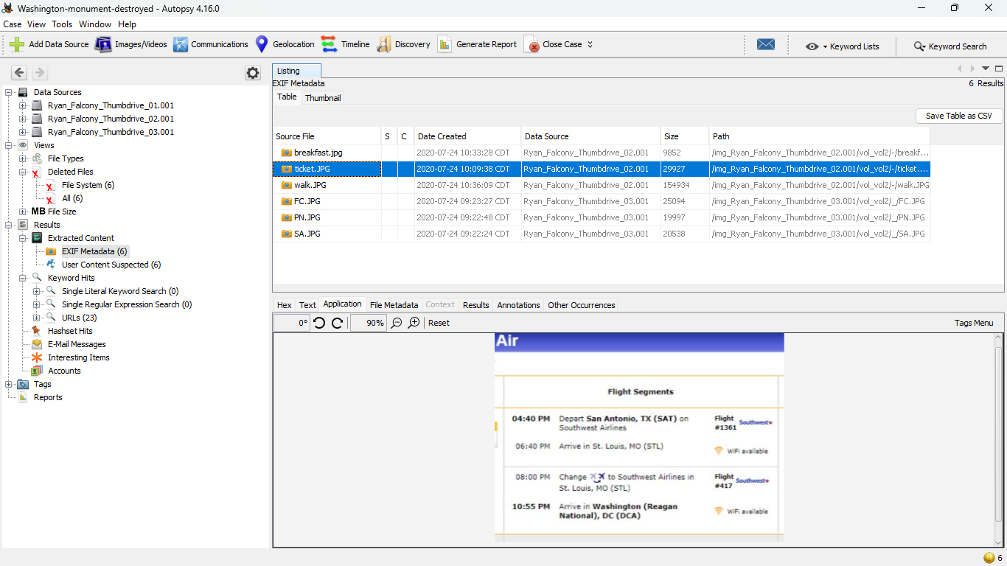

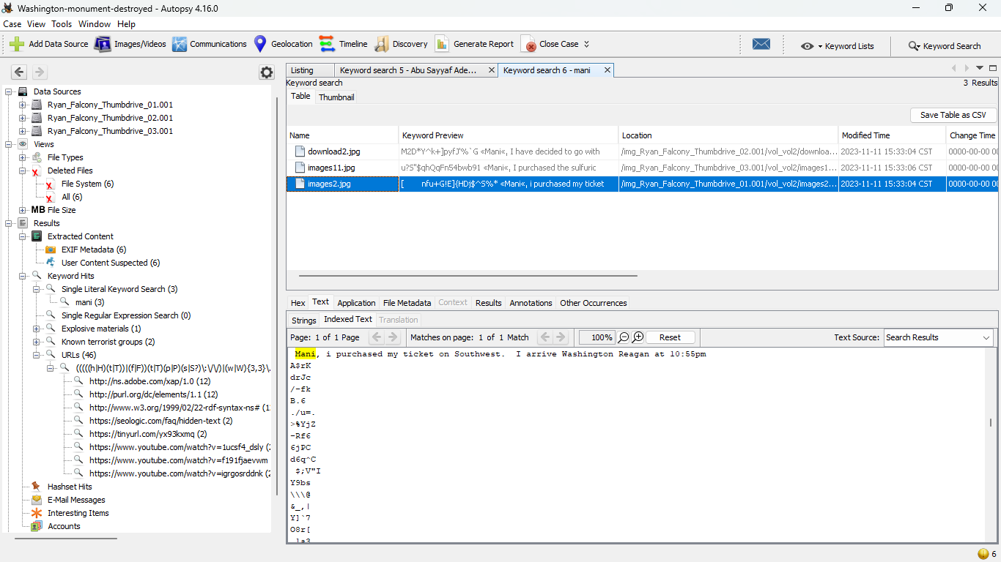

He will stay at a JW Marriot hotel near the monument.

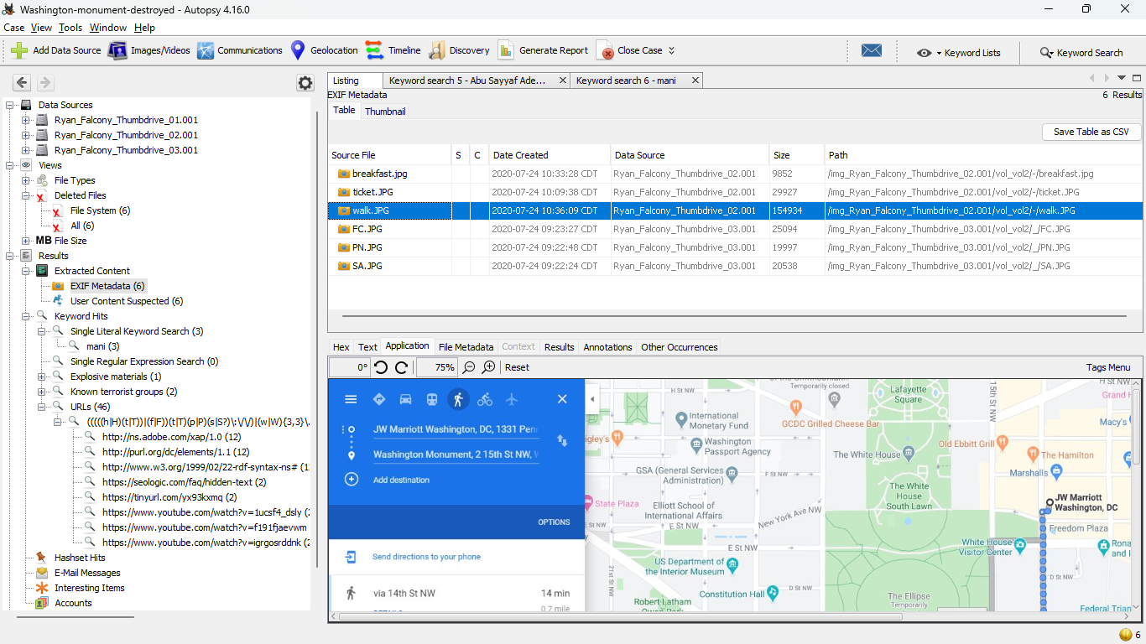

1. Are there any links known to terrorist organizations? Yes, Al-Shabaab

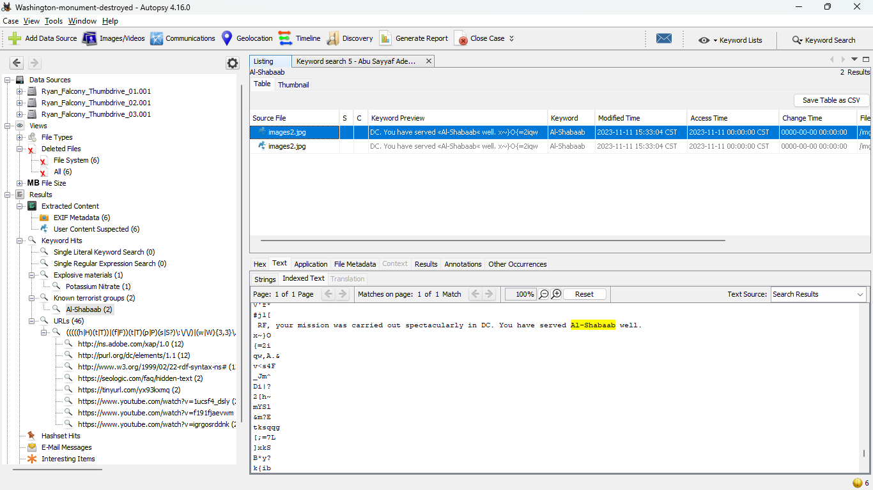

1. Any evidence of contacts Falcony may have had?

I was able to find only one suspect that apparently RF was talking to, which it also appears to be a member of the terrorist group who is only giving out instructions.

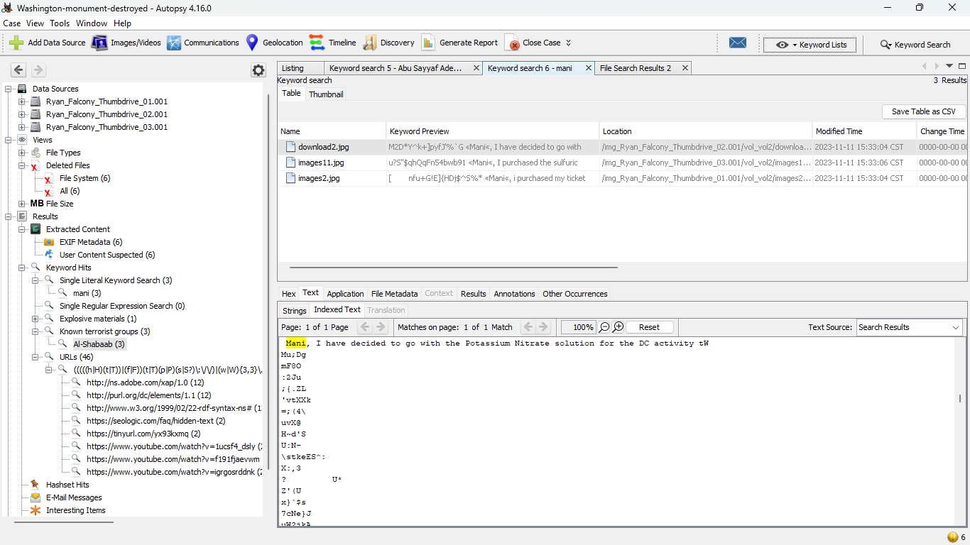



1. What types of explosives were used for this operation? How were they obtained?

The type of explosive materials used for this operation are Potassium Nitrate, Sulfuric Acid, and fuel cubes.

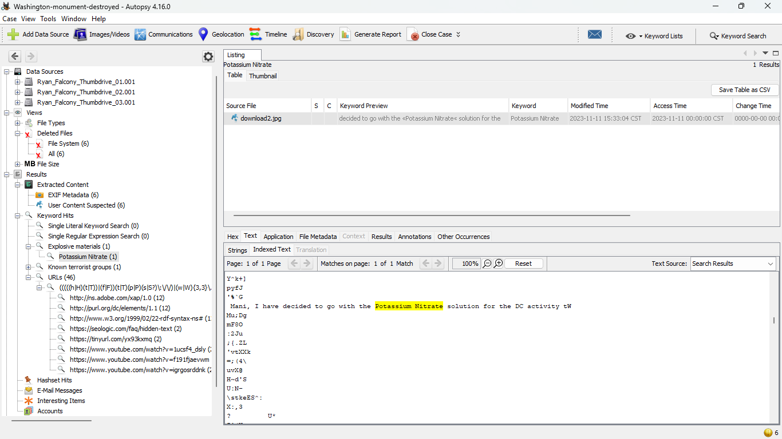

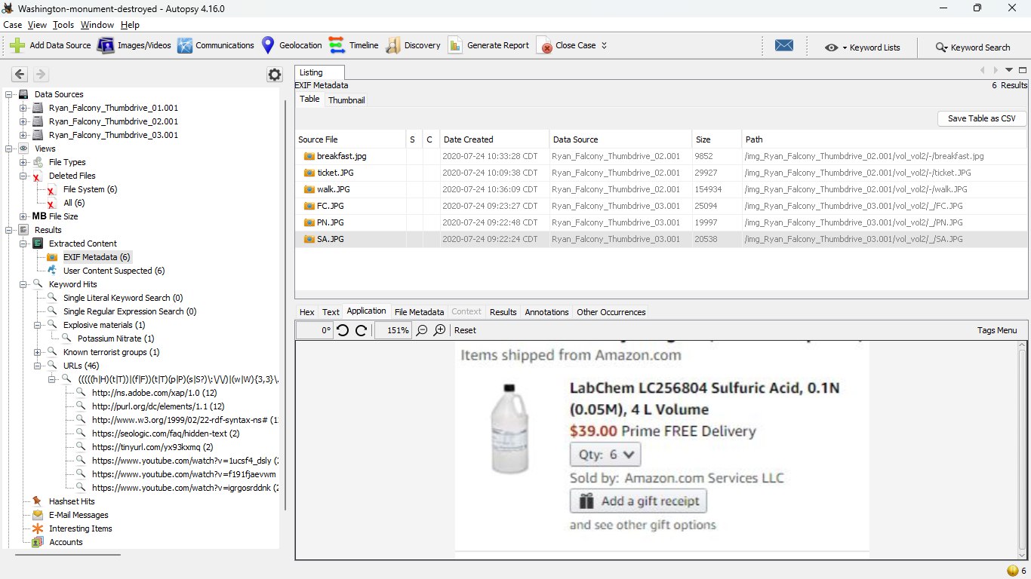



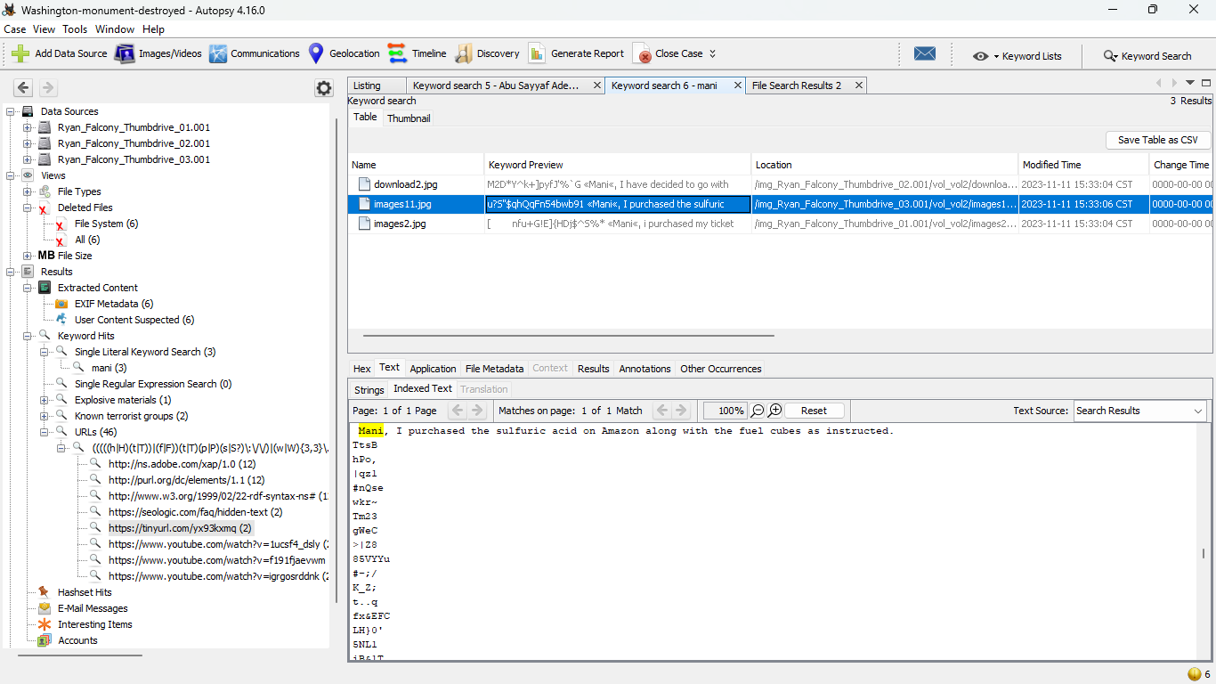



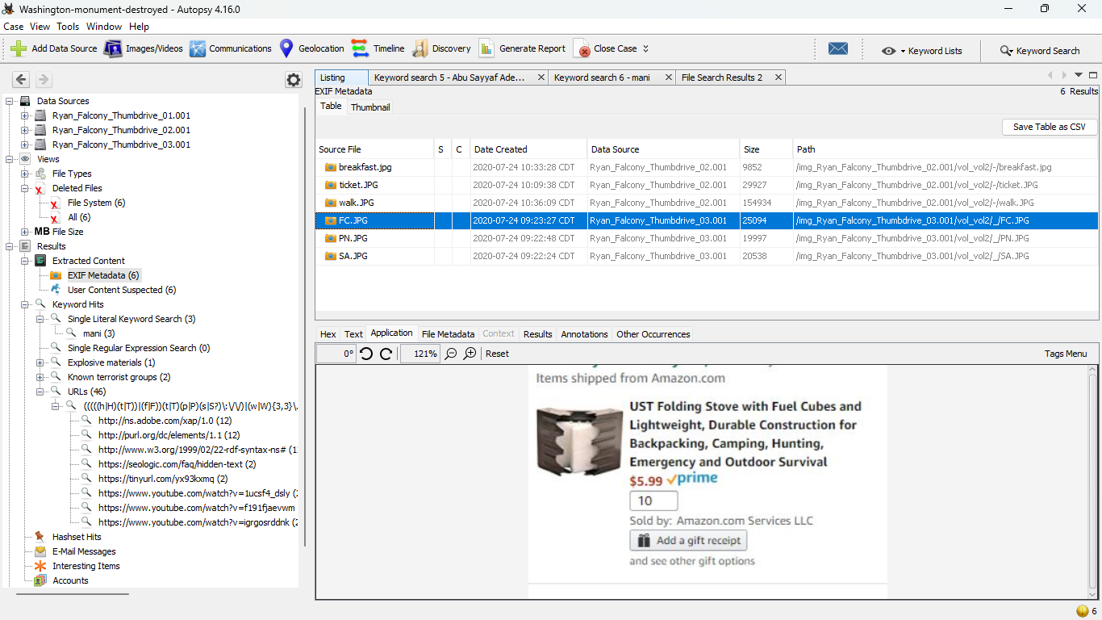

They were obtained from Amazon.



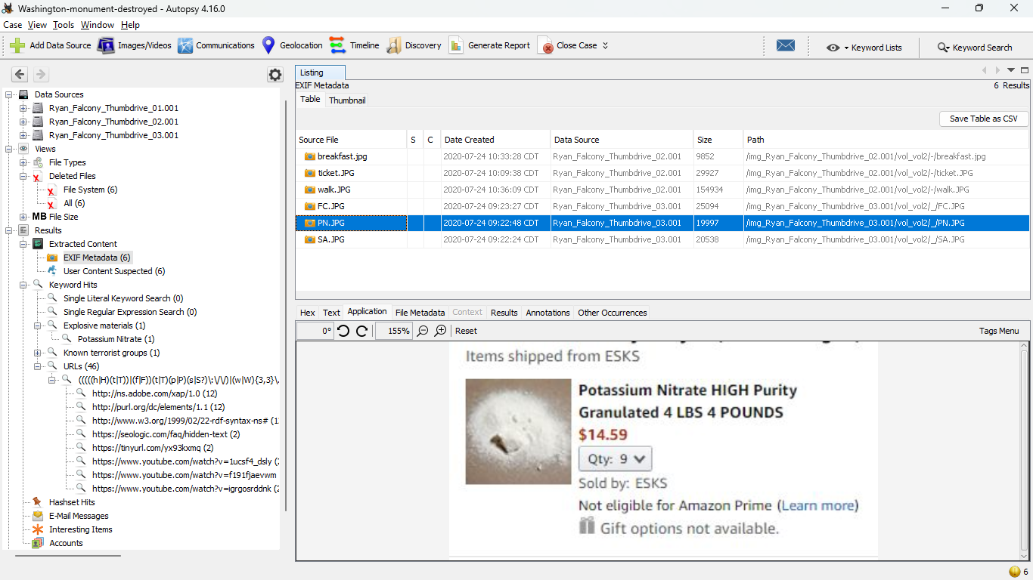



1. Was the picture that was posted on the extremist website located on Falcony’s media? Yes

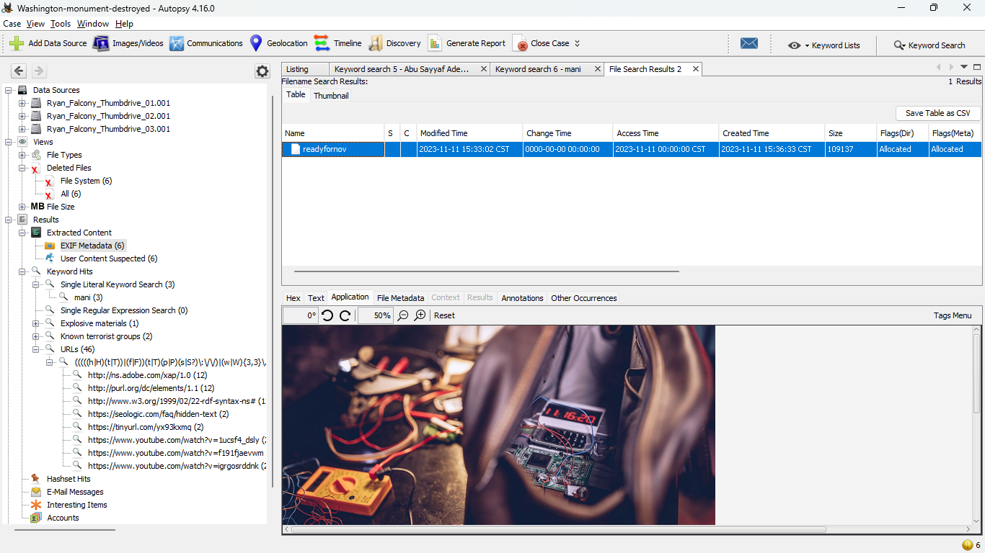

1. How was Falcony trained?

Suspect “Mani” sent him YouTube videos to basically teach him how the IEDs work, how to execute the attack, and finally how to activate the bombs. Here are the videos and their URLs: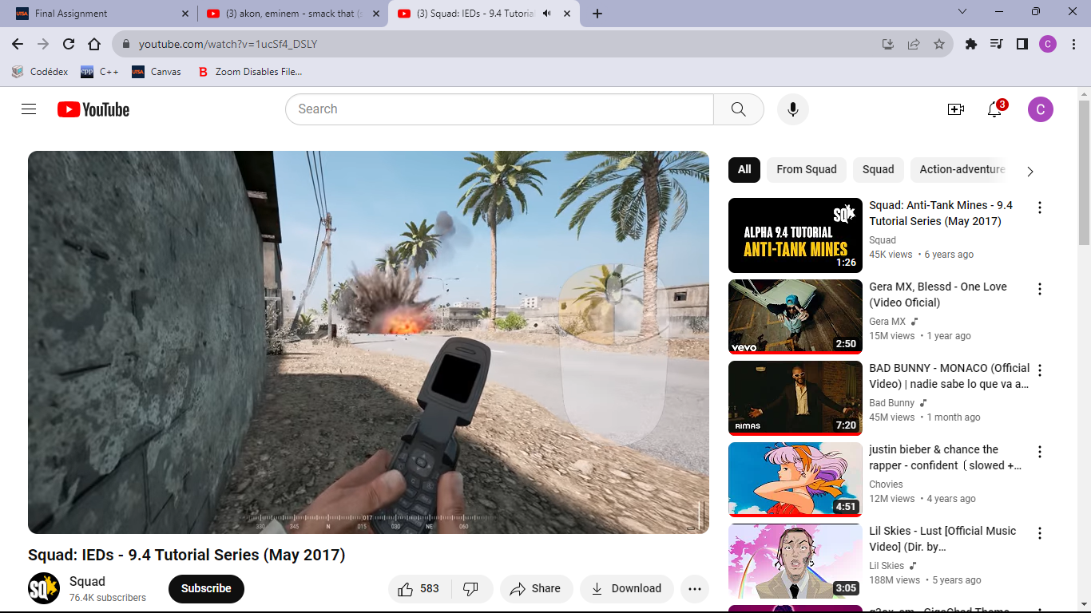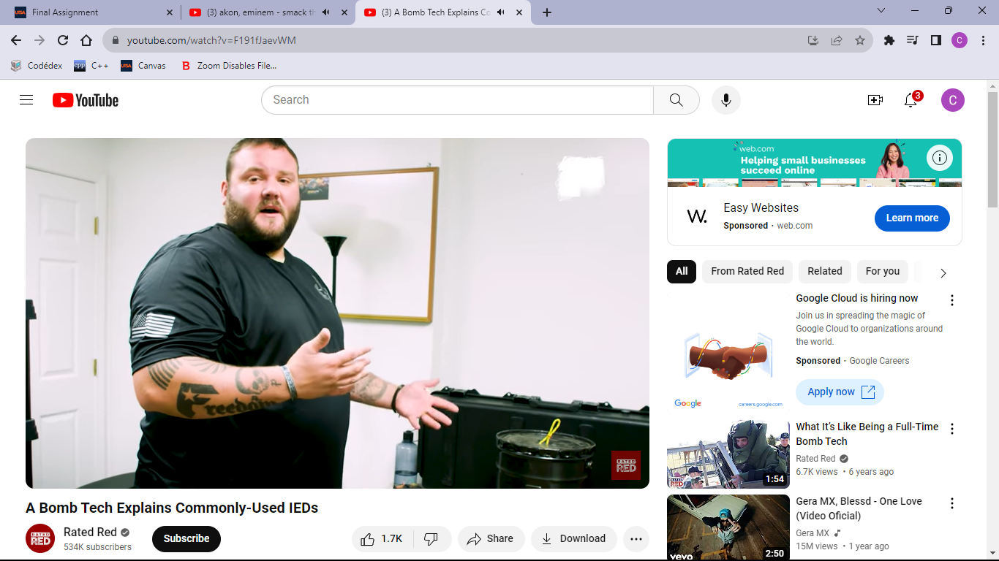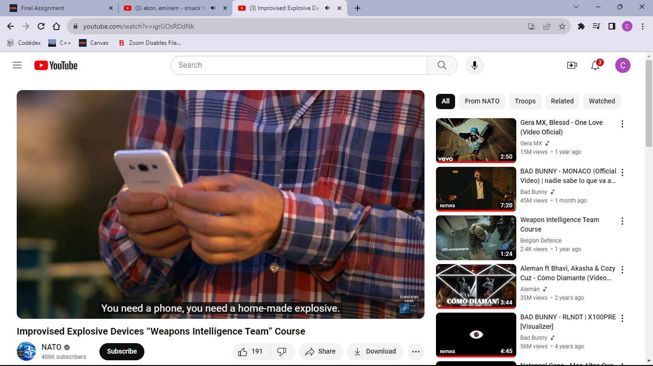



1. **[BONUS]** What is the exact date, time and specific location of the next attack?

At first, I was confused about how to find this information because I have found two URLs that I believed had a strong relation to the next attack, but weren’t working. The URLs were these two:

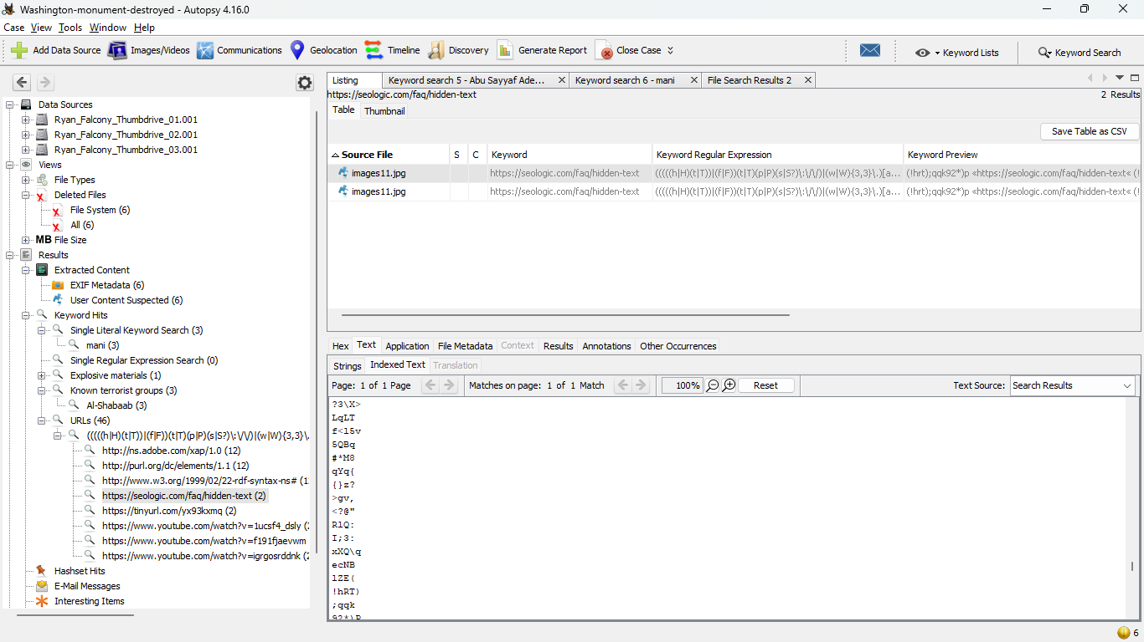

The first one was not loading for some reason so I discarded that URL. The second one did load but it wasn’t showing anything. At that point I kind of gave up (I was about to send an email to the professor asking him why they weren’t working) but realized that since the web page was loading there had to be some information in it. For that reason, I decided to inspect the Page Source and oh well I found a base64 encoded message. I went to the online base64 decoder and this was the message shown:

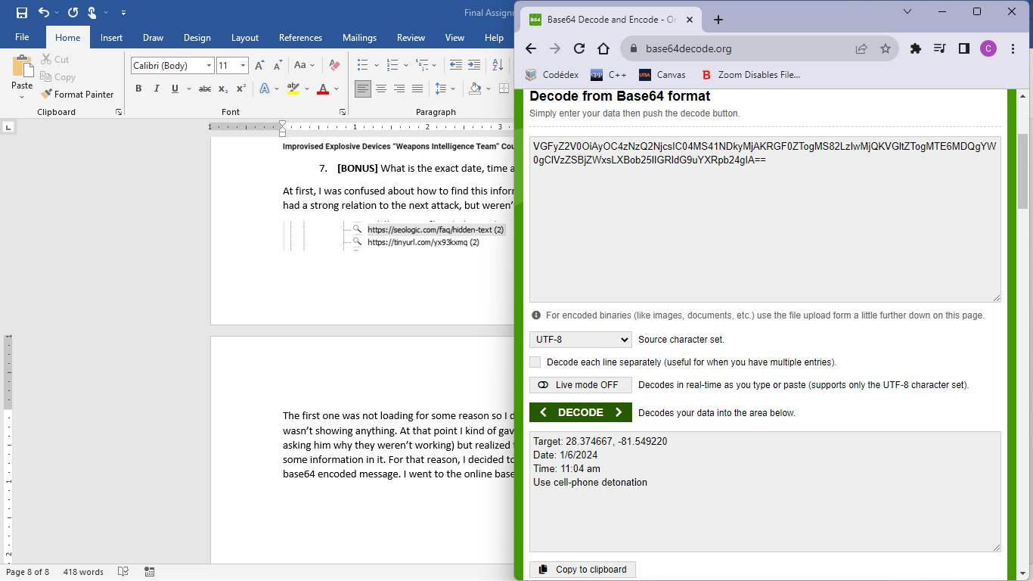

The exact date is 01/06/2024

The exact time is 11:04 am

The location was in coordinate form so I used the Internet to help me find the specific place:

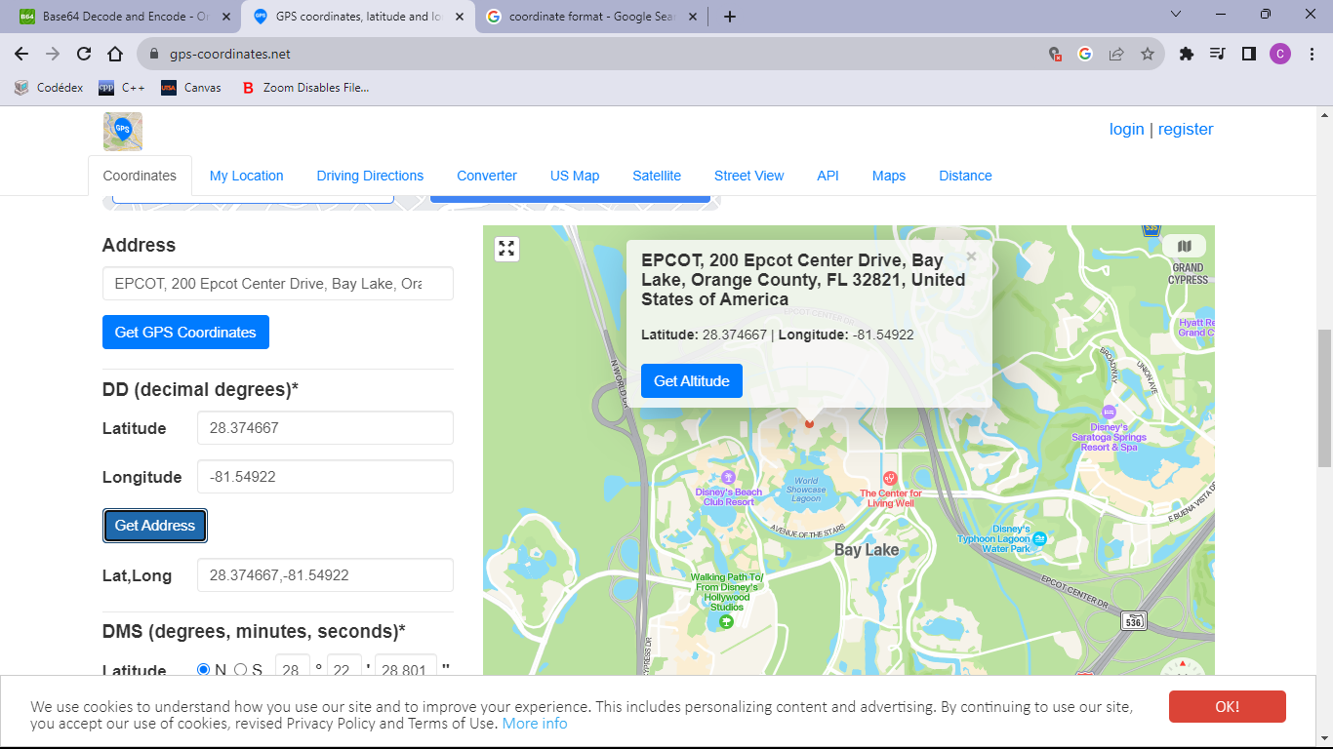

Disney!!!